1. Introduction.
In java we have two packages that contain the necessary classes to make graphic applications. We use java.awt. * And java.swing. *. The first appeared with the first versions of java and has certain limitations although it has classes for buttons, text box, etc. To overcome the limitations of the awt classes, the swing components were added to java, which has the same awt components with certain improvements and some more. Throughout this topic swing components. Starting with version 7, Oracle incorporated a series of independent swing classes to improve the "visual" performance of applications, which is known as JavaFX.
The swing classes are:

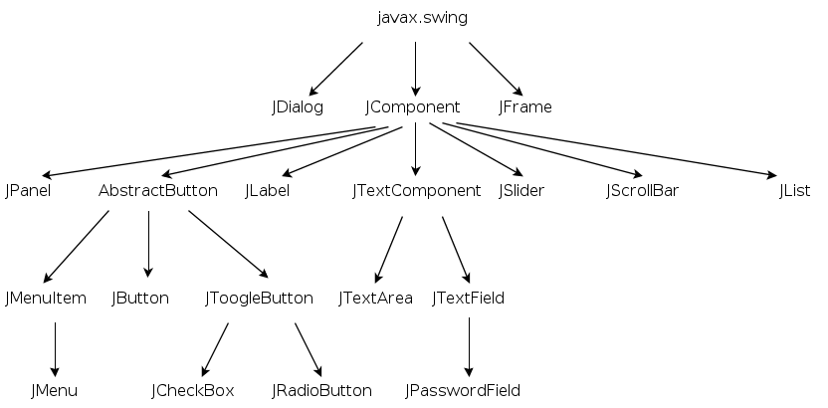

- JDialog will build the dialogs.
- JFrame will be the base for the main application. We will use it for windows.
- The rest of the classes will be simple components. All components inherit from javax.swing.JComponent.

You can check the Oracle page to learn about swing:
http://docs.oracle.com/javase/tutorial/uiswing/
2. A window (or frame).
The simplest graphic application that can be done is a window, we have to do two steps:
1. Create a new class that extends the JFrame class (class for windows) and set some properties.
class frame extends JFrame {
public frame () {
setTitle ("Hello !!!"); // window title
setSize (300,200); // size
// to close the window when the close icon is clicked
setDefaultCloseOperation (EXIT_ON_CLOSE);
}
} // end of frame
2. Instantiate this new class and make it visible:
frame f = new frame ();
f.setVisible (true);

3. Panels
Now we know how to make a window (frame) that closes. We could start adding buttons, scrolls, text fields ... and everything we need, but it is not considered a good programming practice to add components directly on a "heavy" container (frames and applets as far as we are concerned).
The correct thing is to add one or more panels to this and add what we need to the panels. One of the advantages of adding panels onOur frame is that the panels when deriving from JComponent have the paintComponent method that allows drawing and writing text on the panel in a simple way.

class frame extends JFrame {
public frame () {
setTitle ("Hello !!!");
setSize (300,200);
setDefaultCloseOperation (EXIT_ON_CLOSE);
// I create an object of type JPanel
JPanel panel = new JPanel ();
// I add the panel to the frame
add (panel);
// I put the background color of the panel red
panel.setBackground (Color.red);
}
} // of frame

Now we would have a panel "superimposed" on the window.

4. JButton.
The time has come to introduce a component other than a mere container. Let's start with a button. Creating a button is as simple as:
JButton button = new JButton ();
If we want the button to appear with a text label:
JButton button = new JButton ("text goes here");
To add a button to our example program:
class frame extends JFrame {
public frame () {
setTitle ("Hello !!!");
setSize (300,200);
setDefaultCloseOperation (EXIT_ON_CLOSE);
JPanel panel = new JPanel ();
add (panel);
panel.setBackground (Color.red);
// instantiate a button
JButton button = new JButton ("text goes here");
// set the button dimensions
Dimension d = new Dimension ();
d.height = 40;
d.width = 100;
button.setPreferredSize (d);
// add the button to the panel
panel.add (button);
}
} // of frame

5. Events.
In graphical interfaces, execution is event-driven, that is, the program is generally waiting for some user action (pressing a button, filling a text field, etc.) that will trigger an event. This event will be captured by a listener who will execute the corresponding code in response to the user's action. Each of the swing components can respond to a series of events (keyboard, mouse, ...) it will be necessary to add a listener to each componentWe want you to respond to an event. Each swing object can respond to certain types of events.
Listeners must therefore rewrite one or more of the methods.
For example, in point 4 we have added a button to our panel, but when we clicked the button it did nothing. For that we need to add a listener:
// class to listen to button events
class listener_button implements ActionListener {
// The actionPerformed method has to be rewritten, it is the one that responds to the button click
public void actionPerformed (ActionEvent e) {
panel.setBackground (Color.blue);
}
} // from listener_button
Furthermore, when a button is instantiated, we must add this listener that we have just defined, in our example window:
class frame extends JFrame {
public frame () {
setTitle ("Hello !!!");
setSize (300,200);
setDefaultCloseOperation (EXIT_ON_CLOSE);
JPanel panel = new JPanel ();
add (panel);
panel.setBackground (Color.red);
JButton button = new JButton ("text goes here");
// add the listener created earlier:
boton.addActionListener (new listener_boton ());
Dimension d = new Dimension ();
d.height = 40;
d.width = 100;
button.setPreferredSize (d);
panel.add (button);
}
} // of frame
Now our example will have a button that turns the panel blue.
6. Layout managers.
A free translation of the term layout manager would be content manager and that's really what it is. A layout manager is nothing more than a delegate who is in charge of organizing the components that are part of a container, such as a window. The layout manager is in charge of deciding in which positions the components will be rendered, what size they will be, what portion of the container they will cover, etc ... All this is done in a transparent way to the programmer, which therefore saves having to write a lot of control lines.
In order to understand the operation of layout managers, a small basis is needed on what containers and components are.
A container is a Java component that can contain other components. The main class is java.awt.Component from which components like java.awt.Button, java.awt.Label, etc ... are inherited, and the java.awt.Container class representing a container object is also inherited .
A very important aspect to keep in mind is that each container has a default layout manager. In the following table we can see the layout managers assigned by default to each container.
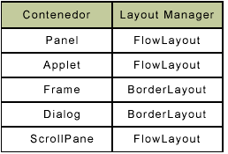
With layout managers, certain positions are specified in a panel, frame or applet where we will add our components or a new panel, to which we can also add a layout in whose positions we can add components or more panels with layouts .... The possibility adding several panels to a layout and fixing these new layouts gives great dynamism when it comes to placing the components.
There are several types of layouts and each one acts in a different way. We are going to see the simplest ones: flowlayout, gridlayout and bordrlayout.
FlowLayout
It is the one with the default panels. Objects are placed in rows in the same order in which they were added to the container. When one row is filled, the next one is passed.
It has three possible constructors:
FlowLayout ();
Create the layout without adding the components, with the edges of some glued to others.

FlowLayout (FlowLayout.LEFT [RIGTH] [CENTER]);
Indicates the alignment of the components: left, right, or center.
FlowLayout (FlowLayout.LEFT, gap_horizontal, gap_vertical);
In addition to the alignment of the components, it indicates a gap between the different components, so that they do not appear to be glued to each other.
Here's an example of using FlowLayout:
class frame extends JFrame {
public frame () {
setSize (300,200);
// create a flowlayout
FlowLayout fl = new FlowLayout (FlowLayout.LEFT, 5, 10);
JPanel panel = new JPanel ();
add (panel);
// add the layout to the panel
panel.setLayout (fl);
// to see the effect I create 4 buttons and add them to the frame
for (int i = 0; i <4; i ++) {
JButton button = new JButton ("Button" + (i + 1));
button.setPreferredSize (new Dimension (100,25));
panel.add (button);
}
}
}
GridLayout
As its name suggests, it creates a grid and adds the components to the grid of the mesh from left to right and from top to bottom. All grids will be the same size and will grow or become smaller to fill the entire container area. There are two possible constructors:
GridLayout (int rows, int columns);

You will create a mesh layout with a number of columns and rows equal to that specified.
GridLayout (int columns, int rows, int gap_horizontal, int gat_vertical);
Specifies vertical and horizontal spacings between grids. Spacing is measured in pixels. Let's see an example:
class frame extends JFrame {
public frame () {
setSize (300,200);
// create a gridlayout
GridLayout grid = new GridLayout (3,2, 5,5);
// rows = 3, columns = 2, horizontal gap = 5, vertical gap = 5
JPanel panel = new JPanel ();
add (panel);
// add the layout to the panel
panel.setLayout (grid);
// to see the effect I create 6 buttons and add them to the frame
for (int i = 0; i <6; i ++) {
JButton button = new JButton ("Button" + (i + 1));
button.setPreferredSize (new Dimension (100,25));
panel.add (button);
}
}
}

BorderLayout
This layout has five predetermined zones: they are north (NORTH), south (SOUTH), east (EAST), west (WEST) and center (CENTER). The north and south zones when changing the size of the container will be stretched to the sides to occupy the entire available area, but without varying its size in the vertical direction. The east and west zones exhibit the opposite behavior: they will vary in size in the vertical direction but never vary in the horizontal direction. As for the central zone it will increase or decrease in all directions to fill in all the vertical and horizontal spaces between the north, south, east and west areas.
It has two builders:
BorderLayout ();
which will create the layout without further ado and
BorderLayout (int gap_horizontal, int gap_vertical);
It will create the layout leaving the horizontal and vertical gaps between its different areas.
When adding more panels or components to this Layout there is a small difference compared to the other two: in the others we were adding components and he was placing them in a certain order, here we specify in the add method the region where we want to add the component:
panel.add (component_to_add, BorderLayout.NORTH);
With this call to the add method we will add the component in the north area. Changing NORTH for SOUTH, EAST, WEST, CENTER we will add it in the corresponding region.
Let's see an example:

class frame extends JFrame {
JPanel panel = new JPanel ();
private JButton blue, pink, yellow, green;
public frame () {
setTitle ("Example with several buttons");
setSize (500,400);
setDefaultCloseOperation (EXIT_ON_CLOSE);
panel.setLayout (new BorderLayout ());
blue = new JButton ("Blue");
Dimension d = new Dimension ();
d.height = 40;
d.width = 100;
azul.setPreferredSize (d);
green = new JButton ("Green");
d.height = 40;
d.width = 100;
verde.setPreferredSize (d);
yellow = new JButton ("Yellow");
d.height = 40;
d.width = 100;
yellow.setPreferredSize (d);
pink = new JButton ("Pink");
d.height = 40;
d.width = 100;
pink.setPreferredSize (d);
panel.add (blue, BorderLayout.SOUTH);
panel.add (green, BorderLayout.NORTH);
panel.add (yellow, BorderLayout.EAST);
panel.add (pink, BorderayLout.WEST);
add (panel);
panel.setBackground (Color.red);
}
} // of frame

In BorderLayouts it is not necessary to define all regions, for example in the previous code we have not added anything to BorderLayout.CENTER

